Data Terminal Window

Jim Hargrave W5IFP

1.0 GENERAL

The Data Terminal emulates a standard terminal program and provides the interface between Logger32 and Terminal Node Controllers.

It interfaces with generic standalone TNC2 and the multimode TNCs, such as KAM, PK-232, PK-900 and MFJ-1278. The program provides for mode changes with the click of the mouse. It does not support modems that depend on the software to provide the AX.25 packet protocol.

Operation of the Data Terminal is accomplished in much the same fashion as the Sound Card Data window. Many of the same Macros are available to make communications easier for the user.

2.0 SETUP

Initial setup is accomplished by opening the Data Terminal and selecting the Config menu item and then Port setup.

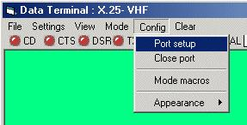

DTW_1

This will open the Comport Setup dialog box that allows you to set your serial port parameters. These must match the TNC terminal settings. Click on Apply to save the settings and close the window.

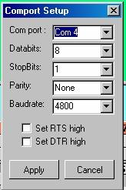

DTW_2

3.0 MODE MACROS

If you have a multimode TNC, then you need to set up the Mode Macros. The Logger32 default settings are for the KAM, If you use a KAM the settings are already incorporated. If not then they must be tailored for your TNC. Select the Config and Mode macros menu items. This will open the Setup Mode Macros dialog box allowing you to label (left side) and build the command structure (right side). Just click on the left box and type the desired mode. Then click on the <Show Macro> button in the middle and the right side is where you can type in the commands for that mode. After you have entered all the commands for the modes. Select the <Apply> button to save the data and close the window. To change TNC modes you just click MODE and select the desired mode and the TNC should go into the selected mode.

Note: Each of the 10 Mode lines will support up to 36 Programmable buttons. The user can define more than one Mode line to the same mode, permitting more than 36 Macro buttons. This would allow establishing distinctive Macros for specific contests, etc. This feature is especially useful since most Multimode TNCs don’t have 10 different operating modes. To use this expanded feature, the user can list the same mode in more than one line and include a duplicate set of commands for each one.

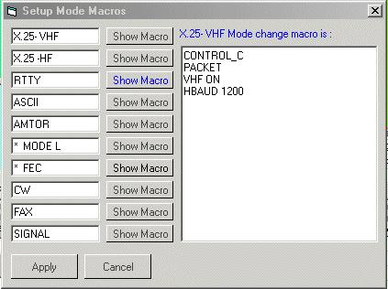

DTW_3

4.0 LOGGING

You can enter data into the Logbook Entry window in the same fashion as the Sound Card Data window. A left-click on a callsign in the received text will automatically enter it into the Logbook Entry window callsign pane. A right-click on received text will bring up a selection menu. The following Items are available for direct entry:
SRX, QTH, NAME, CALLSIGN, SELCAL, QSL_VIA, and GRIDSQUARE.

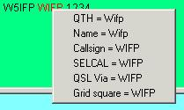

DTW_4

5.0 FILE TRANSFER

5.1 Send a Text file

Select the File menu item in the upper left-hand corner and you will see 4 options. Select the Send a text file menu item and it will prompt you for the path/filename. When you Select the <OK> button or double-click the file, it will automatically be sent to the TNC. This is an excellent utility to set all the params in the TNC with a setup file in case the TNC goes into never land, or the battery dies.

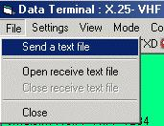

DTW_5

5.2 Receive a Text file

Select the File menu item and then “Open receive text file”. The system will prompt you for the path/filename. Once you select the <OK> button the file will record all incoming data from the TNC. To close this file, select the File menu item and then “Close receive text file".

Note: This is an excellent way to save your TNC params. Once you have the TNC setup and working like you want it, just open a receive text file and give the TNC the dump params command “Disp Z” (PK-232) and it will dump all the settings currently in the TNC. Close the file and edit out all the garbage at the beginning of the file and you will have a good file to set up the TNC as mentioned above.

6.0 DATA TERMINAL MACROS

$band$
$call$
$clear$
control_x
$delay$
See Note 1
$escape$
$log$
$longdate$
$longdateandtime$
$longtime$
$mode$
$mycall$
$name$
$qsy(nn)nnn.(nn)$
$radiofreq$
$receivedrst$
$receivedgrid$
$tncdate$
$rotor$
$selcal$
$sentrst$
$serialnum$
$shortdate$
$shortdateandtime$
$shorttime$
$version$

Note 1: Pauses 250ms before sending next character to the TNC. This is typically used after sending control codes to the TNC to change mode (it takes a finite time for the TNC to get squared away).

7.0 MACRO BUTTONS

The Data Terminal will allow the user to configure up to 36 48 Programmable buttons for each mode of operation. The current programming supports 10 different modes. There is a potential of 360 user-programmable buttons.

The Programmable buttons will support a combination of Macro commands and text to be sent to the TNC. This capability works in the same fashion as the Sound Card Data window. The user can include Macros and TNC control commands embedded into the text.

The control commands are case sensitive. The PK-232 must have the control code in uppercase to work, i.e., <Ctrl+C> in a command Macro can be either “control_C” or CONTROL_C. The word CONTROL is not case sensitive. TNC “control_(x)” Macros do not use the $ preceding and following the command, These commands are interpreted as immediate commands. However Macros do require the $signs$.

7.1 Connect and Disconnect Macros

Packet “Connect” Macro:

control_C ( forces Command mode)
C $call$ ( Callsign from the log Entry window)

Packet Disconnect Macro

control_C
D

7.2 RTTY CQ Macros

The following Macro shows the proper use of the 'X' and 'Control-D' TNC commands embedded in a text Macro. The 'X' command forces the TNC to enter into transparent mode. The 'Control_D' command stops transmission after the transmit buffer has been sent.

Note: Control_D must be added to the end of the text stream. If the 'Control_D' is placed on a separate line, it will cause the error message CMD:"***Transmit Data Remaining" to be sent by the TNC:

Control_C (Forces Command mode)
X (Forces Transmit mode)
"CQ CQ CQ de $mycall$ $mycall$
"CQ CQ CQ de $mycall$ $mycall$ K 'Control_D'

7.3 Logging Macros

Most of the normal logging function Macros that work with the Sound Card Data window are available in the Data Terminal. Consult the MACROS topic to see which ones apply.

